Task: Access the shared folder inside the someone’s private /home/usr.
Concepts and Tools: Permissions, ACL (setfacl), namei,
Done by: Aashish Chaudhary (Feb/11/2026)
Project Overview:
----------------------
This project focuses on Sysadmin Task of working with the files on someone else's private home directory with permissions allocated on the file or directory. By default, only the root user can get into a “some other user’s” private home directory. But what if “ a user” has somefiles, or shared directory inside his own private home directory ? This issue is taken care of in this lab. I am going to breakdown this on a simple way. After reading this, anyone can have their head around what to do or look for in the internet. Let’s dive into it.
Things to Remember:
First of all, In Linux, the security revolves around the concepts of permissions to the directory or files. The ‘chmod’ value defines what the owner or the groups can do to the file or directory. There is also a concept of Access Control Lists (ACL) rule that provides some extra granular control to the permission stuff. For instance, allowing permissions to more than one user or specific group.
What are we even doing on the project?
In this project, try to visualize my environment. In a machine, there’s a user “bhairav0001”. And inside the bhairav0001’s home directory, there is a directory that’s named as “sharedFileDir”. We are going to use this directory for our lab. In a System there are multiple users, off course, each have their own home directory. In my lab I’m trying to share this to-be-shared directory for everyone in a group. I have already created a “developers” group and added users into it. user003 is one of them. Have a look in the following picture.
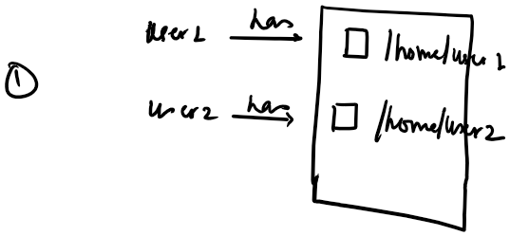
Fig: normal Linux environment
Fig: developers’ group multiple users
Now, let’s have a look at what will even happen in the lab.

Fig: objective goal of our project.

Steps:
- Directory Creation:
    - mkdir command to create sharedFileDir directory. If possible create some files within it and add some text into it.
- Permissions check:
    - Verify the chmod value and check the directory and its recursive files owned by the current user.
- Install acl tool:
We are going to install acl tool, since acl tool is a powerful tool that allows you the powerful control of files permission. So running sudo apt update & sudo apt install acl -y will install acl tool in the system.
- Command:
run setfacl commands to allow the group to have access to directory.
    - Command: “setfacl -R -m g:developers:rwx /home/bhairav0001/sharedFileDir”

Troubleshooting:
Unsuccessful test result after the setfacl command:
- Once the command “setfacl -R -m g:developers:rwx /home/bhairav0001/sharedFileDir” successfully ran, the user003 or the group developer was still not able to access the files in directory.
- After research on online, multiple sources claimed running chmod command with value 710 allows the group to traverse through /home/bhairav001. And even allow the group to access it if they had absolute path to the directory. It did not work at all.
- After trial and error with ‘namei’ tool, I realized the /home/bhairav0001 (upper level) was not allowing the requests to go through it because the group permissions was not allowed for the developers. So again, setfacl -m g:developers:x /home/bhairav0001 solved the issue.
Note: the permission ‘x’ after developers, plays important rule in security. It allows group ‘developer’ to go through it or inside it but not read and do write into it. Only sharedFileDir allows the group to make changes according to defined permissions.
In short, I have tried successfully shared the directory from user bhairav0001’s home directory and have users in group developers access it and make changes to it. Along the way, I encountered the permission issues, and solved it using acl tool. For commands, please review the CLI documentation that includes the steps and Commands to follow.

